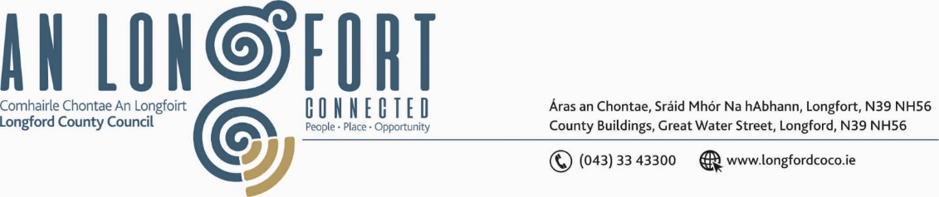

***BALLYMAHON MUNICIPAL DISTRICT***

***Please note meeting will be held in Ballymahon Library.***

**19 September 2024**

**To: Each Member of Ballymahon Municipal District.**

**Dear Member,**

You are requested to attend a Meeting of Ballymahon Municipal District to be held

**in Ballymahon Library** on **Thursday 26 September 2024 at 4 pm** to transact business, as set out on the agenda hereunder.

**Yours sincerely**,

_______________

**Claire McNabola,**

**Meetings Administrator.**

**AGENDA**

Prayer before meeting.

1. Confirmation of Minutes
2. Ballymahon Municipal District Meeting held on the 25 July 2024 – enclosed.
3. Ballymahon Municipal District Committee Meeting held on 25 July 2024 - enclosed
4. Ballymahon Municipal District Annual Meeting held on the 24 June 2024 - enclosed

**2.** Matters arising from Minutes

**3.** Declaration of Interest by Members

**4.** Management Report – enclosed

**5**. Roads - 3 Year Programme

**6**. Community Grants

**7.** Notice of Motions

**Councillor Paul Ross**

1. I call on Longford County Council to look at potential development site on the outskirts of Edgeworthstown with a view to purchase for Housing Development.

**Councillor Sean Mimnagh**

1. I call on Longford County Council to continue with 4 extra, energy efficient lights at Barnacor Lanesboro N63 along the footpath, in the interest of public safety and confidence, for the homeowner's and the people using the footpath to exercise.
2. I call on Longford County Council to resurface the roadway at the public car park from the playground down to the harbour in Lanesboro.

1. I am calling on Longford County Council to provide an update on the extension of the footpath from Silver Birches to the school in Stonepark.

**Councillor Pat O’Toole**

1. I call on Longford County Council to give a commitment to replace the windows and doors in all local authority houses in St.Matthew's Park Ballymahon.

**Councillor Mark Casey**

1. I call on Longford County Council to immediately repair the harbour in Lanesborough as it has fallen into disrepair and is now dangerous.
2. I call on Longford County Council to write to Bord na Mona in Mount Dillan in Lanesborough and request them to remove the trees that are over hanging the wall in Clonbonny graveyard and also request that they cut the hedges that are running parallel to Clonbony/clonflower road.
3. I call on Longford County Council to include a new pathway linking Kilashee to the canal via the Clondra in the 2025 budget.